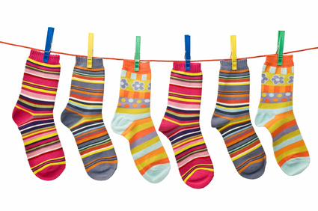
Socktober
Let’s help the JUSD families
by donating 500 pairs of socks

- The class that collects the most socks will win a prize
- Deadline: October 31, 2019

